RazorPages Introduction
Razor Page applications use a PageModel Class approach. What is a PageModel class approach?
- Allows developers to have a clear separation between UI and Processing Logic.
- It provides greater flexibility for teams in that one member can work on the view (.cshtml file) while another can work on the processing logic.
- PageModel class is declared in a separate class file - a file with a .cs extension. 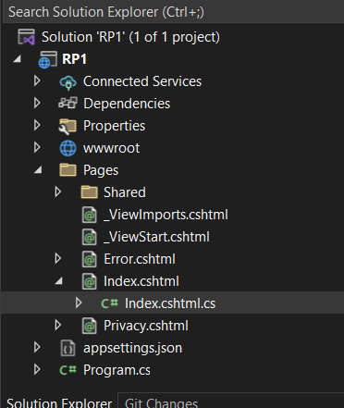
- PageModel classes are placed in the same namespace as the page, which by default follows the pattern <default namespace>.Pages.
- PageModel classes are named after the page file, with "Model" as a suffix. A PageModel class for Index.cshtml will be named IndexModel and will be generated in a file named Index.cshtml.cs.

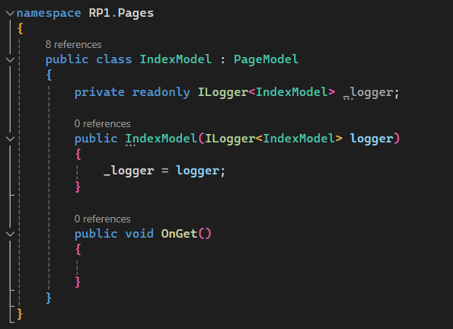

Task1: Identify the difference between Razor Views and Razor Pages
[10 marks]
Razor Views is the layout of the pages (.cshtml) and Razor Pages is the processing logic of the page (.cshtml.cs). This approach allows developers to work on the UI and Logic of the page separately.

Open a new ASP.NET Core Razor Pages project, and name it RP1Tut_[yourStudentNo]. This project must be named appropriately.
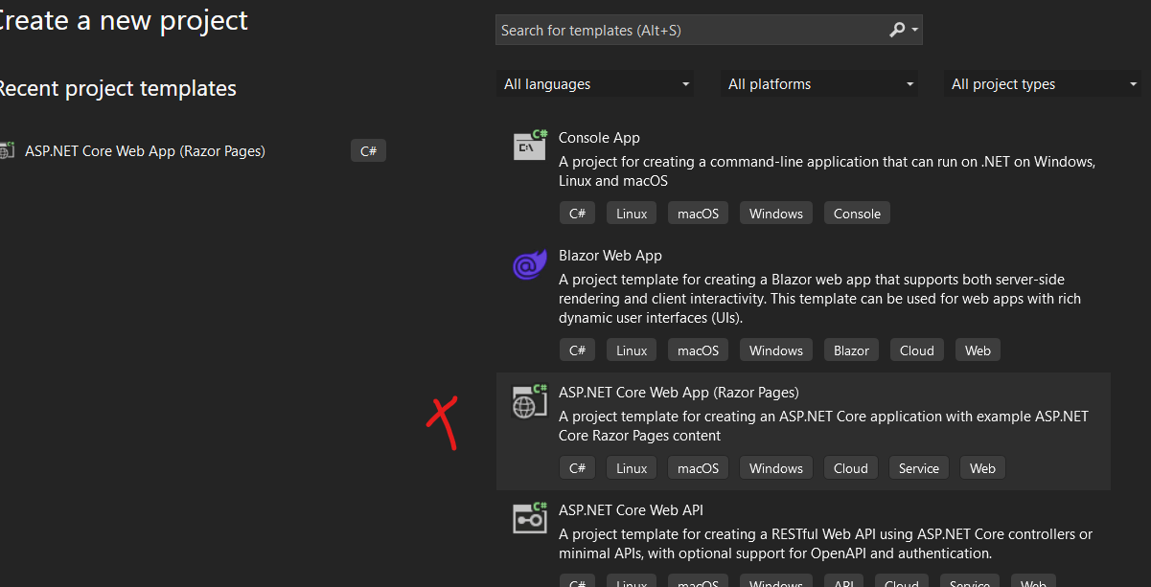

We don’t have Models, Views, or Controller folder in this solution. Instead, we have a Pages folder introduced since .Net Core 2.0. Razor Pages are Page focused.
Disable Nullable through Project Properties.
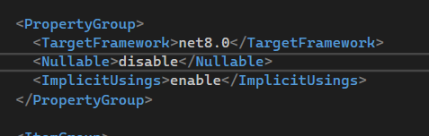

Shared Folder
The Pages folder includes a Shared folder similar to our MVC projects.
Default master page is _Layout which is a partial view denoted by the underscore. This layout partial view is called by all other pages. The @renderneringbody tag indicates where the body of the page will be placed.
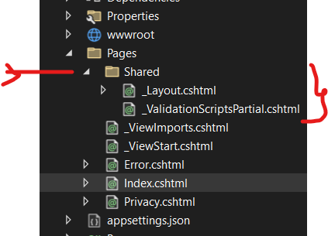

We also have _ViewImports which stores all the global declarations or all the ‘Usings’ for the web application.

Creating the Data Layer
First thing to do is create a Models folder and create your Category class as before. Add the annotations.
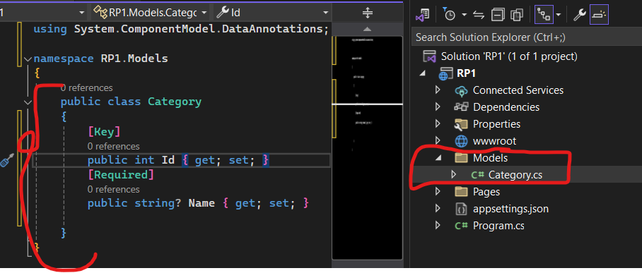
Then create a DataAccess folder to hold the DBContext class. Add the package EntityFrameworkCore.

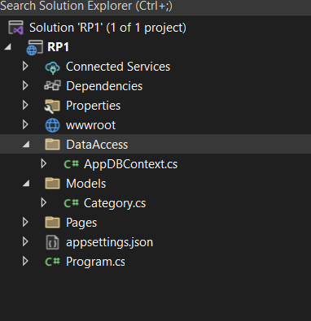
Then add a class called AppDBContext as below. Add the property Categories which is of type DbSet<Category>.
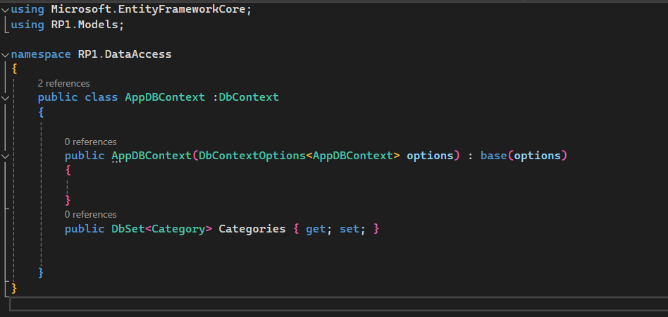

Dependency Injection
We can register a number of services through Dependency Injection. A service can be a Logging service, Database Service or other. Dependency Injection works by using a DI Container with service instances. Then when we need to use an implementation of the service, we can use a constructor of the PageModel class to tell it which implementation we need e.g. DbContext, Logging, Interfaces etc.

This time we will use DI to get an implementation of the DbContext class. Ensure that you add the service for the database context within Program.cs
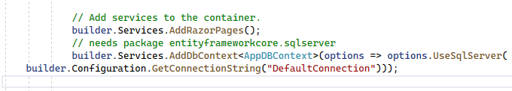

Adding Nugent Packages
Add the Nugent package EntityFrameworkCore.SqlServer and EntityFrameworkCore.Tools.

Add ConnectionString to AppSettings.Json file
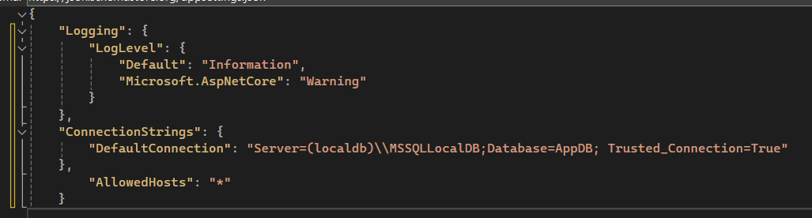

Note: Implement Azure SQL Server.
If anyone wants to use an Azure SQL Server, its free and doesn’t require any extra code apart from changing the connection string. Ask me in class to show you how to create a SQL Server through the MS Azure platform.
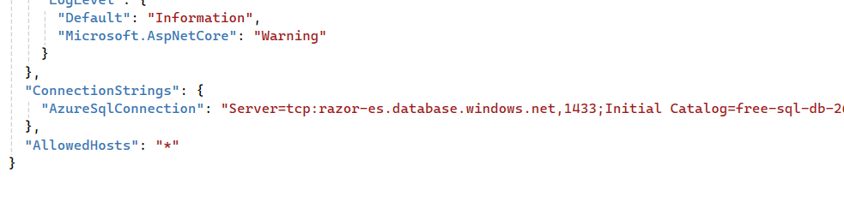

Create Migrations and Update Database
Run the migrations and update the local SQL Server.
From Package Manager console, run add-migration [ver1] and if it succeeds, run update-database.

Task 2: Show the AppDB database created with a few sample records in the Category table. [10 marks]
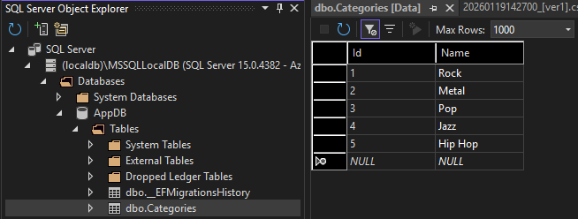

Razor Pages
Next, we want to add a Page for Categories CRUD operations.
Add a folder called Categories under the Pages folder. Inside this folder add an empty Razor Page called index.cshtml.
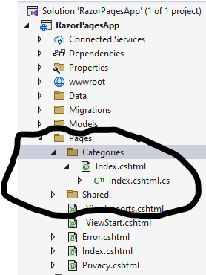

Each page created has an associated PageModel file. The Index.cshtml.cs will store the controller code which will respond to HttpGet requests etc.
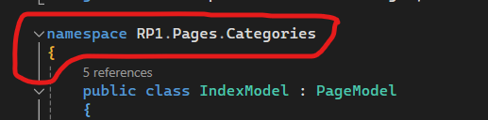
The namespace should list the physical folder structure in the project solution.
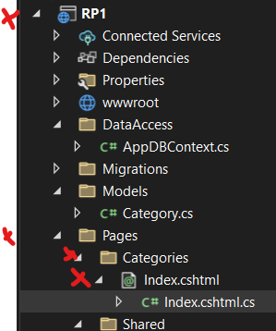
The IndexModel class associated with the Index page is a subclass of the PageModel class which handles HttpRequests and Responses.
The OnGet is a handler which will execute when a HttpGet request is made. We will also add an OnPost handler which will handle the HttpPost requests.
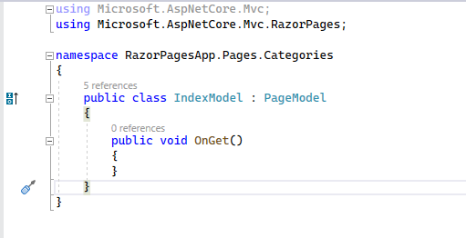

Inside the actual Razor Page(.cshtml file) , we declare the model to be used which in our case is the public IndexModel class as below. This must match the name of the PageModel subclass.
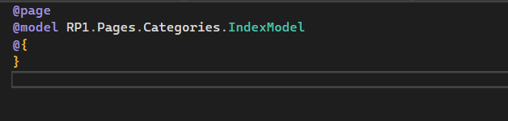
Connect to Database
Next we want to make a connection to the Category table using our DbContext class. We have already registered our DbContext service with the DI Container within Program.cs, so we now need to access an implementation of this class using the following code;
- Inside the IndexModel class, create a readonly private instance of the DbContext class.
- Then using a constructor for the IndexModel class, assign the private variable to an implementation of the DbContext implementation.

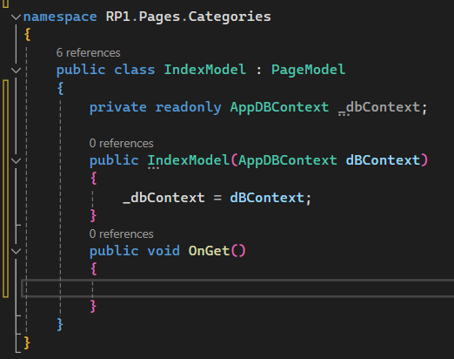

Next, we need to instantiate a new IEnumberable<Category> object to store all Category records. So when the user opens the index page, all the Categories will be returned through the OnGet() handler method.
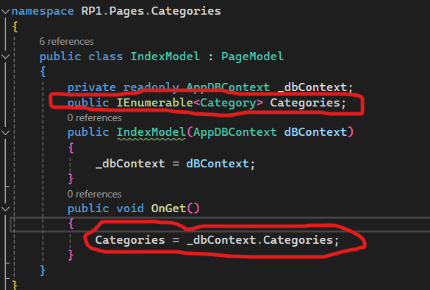

Routing in Razor Pages
Now we need to route to this Category Index page. Go to the master layout page _layout.cshtml.

Add a new item to the navigation bar - Categories/Index as below;

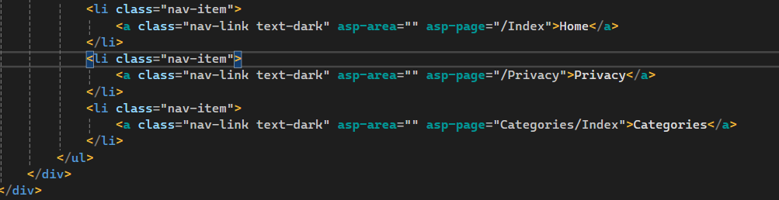

Routing with Razor Pages.
Routing with a PageModel is performed using handler methods which are analogous to Action methods on an ASP.NET MVC controller.
A handler method selection is based on matching the HTTP verb(get, post) which will be prefixed with the word “On”. So OnGet or OnPost for example.
When the page is first navigated to, the HTTP GET verb will be used for the request, firing the OnGet() handler.

When the "Click to post" button is pressed through a form, the form is posted and the OnPost() handler fires.

Task 3: What is the difference between OnGetAsync handler and OnGet handler [10 marks]
OnGet is a synchronous handler. It executes code sequentially and blocks the thread until the operation completes. It is suitable for simple and fast operations that do not involve input/output tasks, such as assigning values or working with in-memory data.
OnGetAsync is an asynchronous handler that uses the async and await keywords. It does not block the thread while waiting for long-running or I/O-bound operations such as database access, API calls, or file operations. This improves application performance and scalability, especially in high-traffic web applications.
.

Display Category Records
Now inside our RazorPage, we will add code to display the category records.

Note: The properties and methods that you apply to the PageModel class (.cs file) are available with the Model property in the Razor Page (.cshtml). The properties can be simple ones like string, int, DateTime etc, or they can be complex classes, or a combination. Each time you want to refer to a property, just use the @Model.PropertyName within the Razor Page.

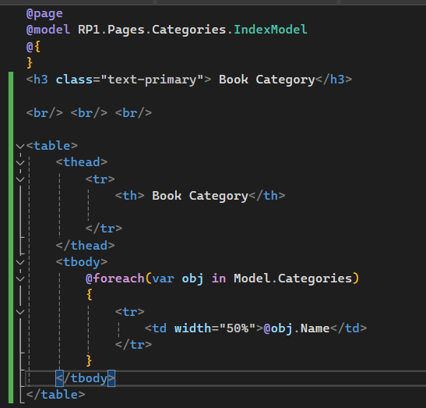

Save changes and run application.

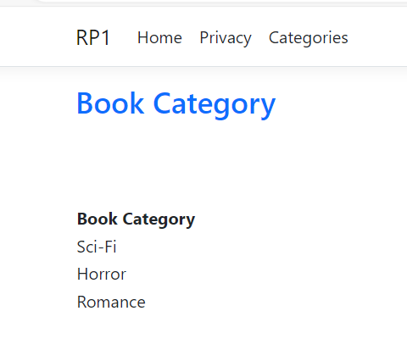

We can add some Bootstrap classes to the table.
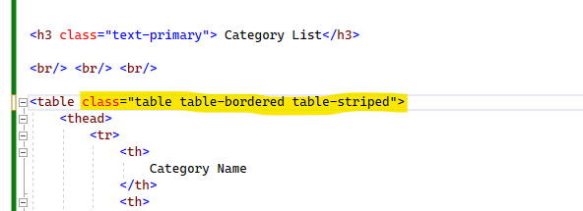

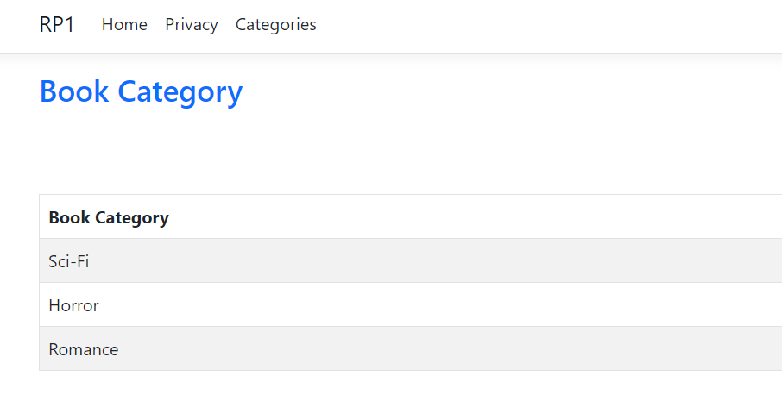

The Create Category Page
Next, we will create a form which will take input from the user and store it in the Category table.
Add a new empty Razor Page called Create.cshtml with the following code below;
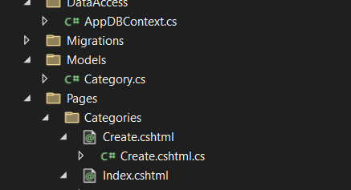

Add a button to the Index.cshtml page to connect to the Create.cshtml page. We will use some of the Bootstrap classes to create a container and place heading and button along side each other.

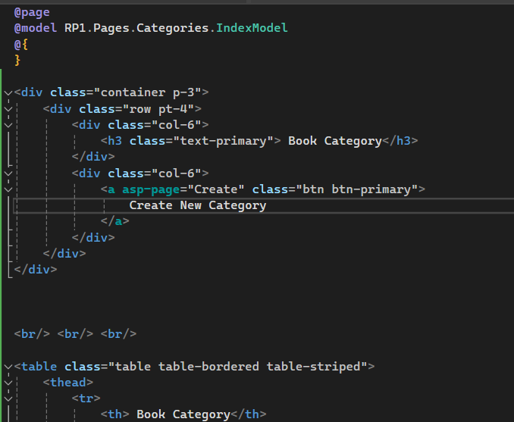

Task 4: List the functions of the following
class= row pt-4 - Create a horizontal layout row with top padding
class= col-6 - Creates a column that takes up half the width of its row
<a asp-page=”Create” - Creates a link that navigates to the Create Razor Page
[10 marks]
Save changes and view UI.

When we click on Create button, it will take us to the Create.cshtml page which displays the form.

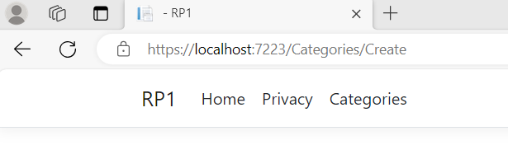

Binding to a Model
If we want to bind the input controls of a form to a data Model, we need to instantiate a Category class within the CreateModel class first.

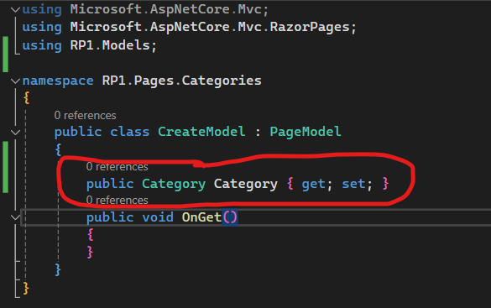
Inside our Create.cshtml Razor Page, we create a <Form method=”post” > tag
Create input controls and bind to @Model.Category.Name

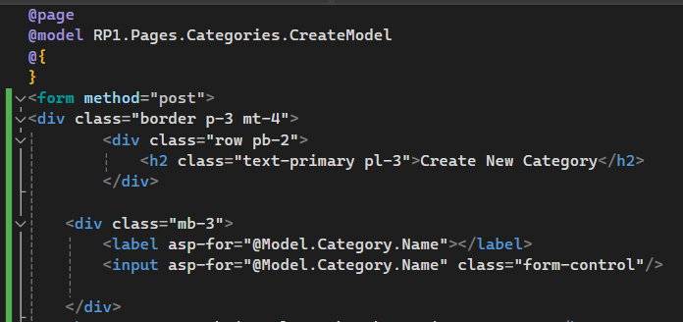

Save Changes.
Add a submit button to the form to create the new record.
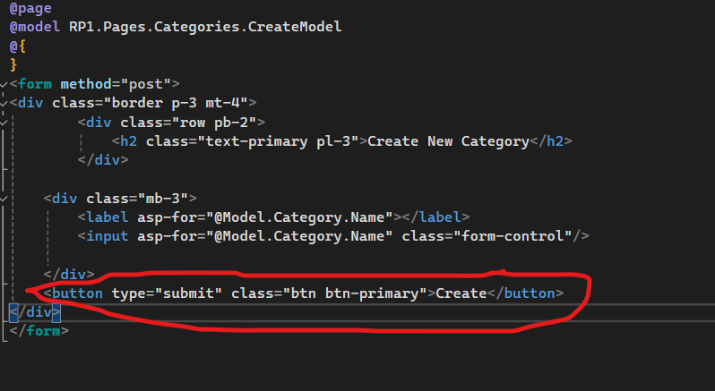

Save Changes and Run Application.

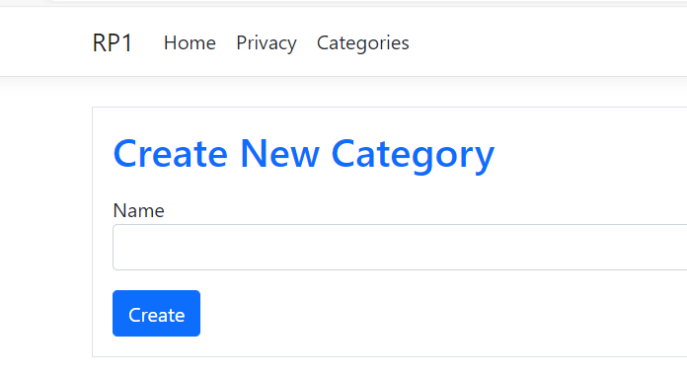

Creating the OnPost Handler for Submit Button
Now we need to create an OnPost handler to save the form data to the Categories table.

We have already registered our DbContext service with the DI Container so we now need to access an implementation of this class using the following code;
- Inside the CreateModel class, create a readonly private instance of the AppDbContext class.
- Then using a constructor for the CreateModel class, assign the private variable to an implementation of the AppDbContext implementation.

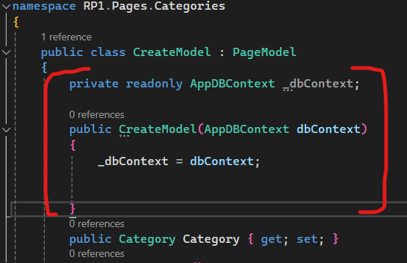

Next we will create a OnPost handler passing in the Category object retrieved from the Page form.
We then add and save changes to the database. Notice we use Async methods. This provides better scalability and performance. We will return to the Index page once complete, so we need to have the return type IActionResult.

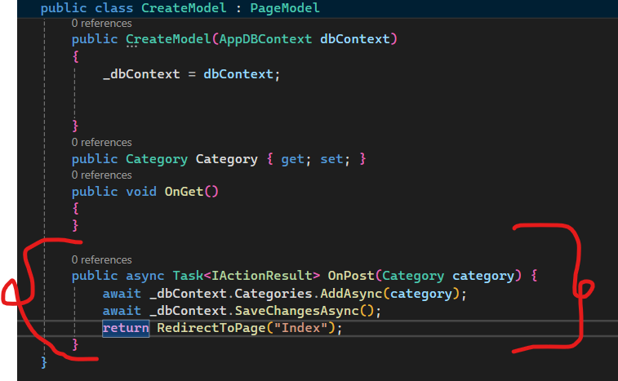

Save changes and run application. Ensure it has saved record to table.
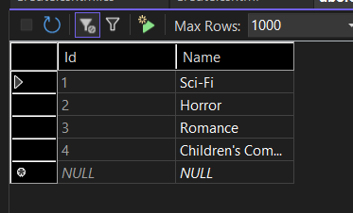
Validations on the New Record - Server-Side Validation
With .Net core we can check whether the model state is valid or not. In other words, the data entered is valid record for a Category table. The validation is taken from the Model class Category.cs.

If modelState is valid, go ahead and add record to Category table, if not, return back to the same view with the same object.

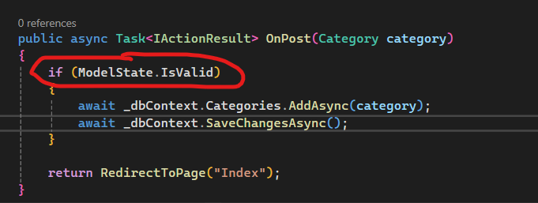

Asp Tag Helpers
There are asp-validation tags which return default information from a form. Lets add a asp-validation-for tags for the Name.
This will print default error messages to the form if invalid data is entered.
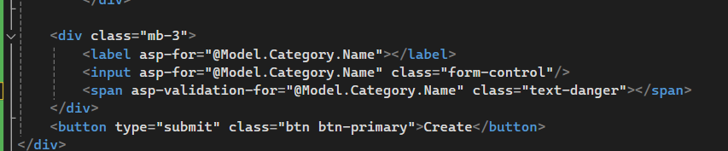

This validation is directly taken from the annotations from the class definition .i.e. Category.cs.
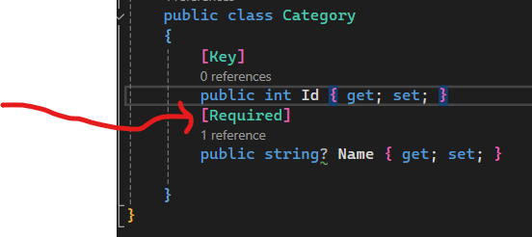

Experiment with these options. All annotations are available from the .Net Learn site.
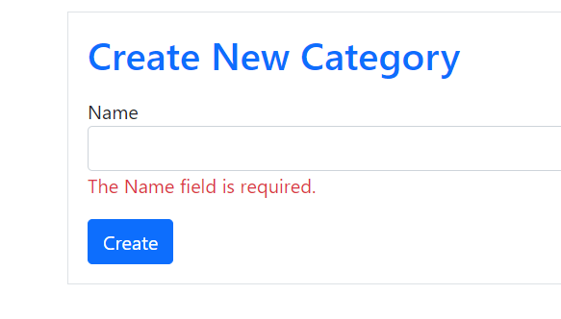

Client-Side Validation
All validation to date would have been checked and generated by the web server. This would seem excessive, especially when we are just validating empty boxes of a form.
Therefore, we can use a custom validation script which is included by default within the Partial View in the Shared folder.

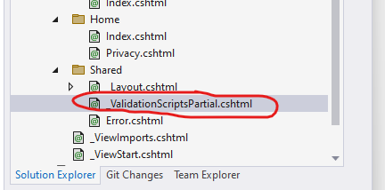

Add a script section to our Create Category Page to initiate the client-side script _ValidationScriptsPartial which will check to ensure if all input boxes have been filled with valid data.

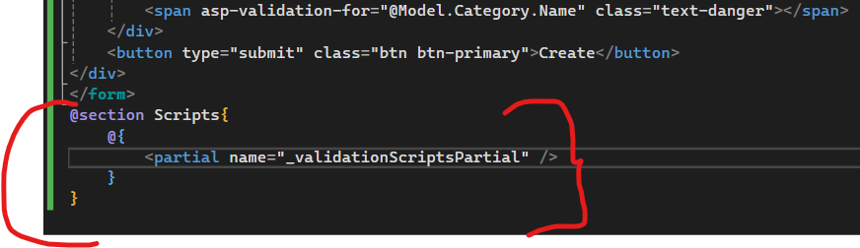

Save changes. You will not notice any changes through the UI but all validation is done on the client side which is less resource intensive.
More annotations are available from Microsoft Site.

Creating the Edit Razor Page
Create a copy of the Create.cshtml

- Rename copy to Edit.cshtml.
- Change PageModel class name to EditModel.
- Change buttons to read Update.
- Change name of class within Edit.cshtml.cs file to EditModel.
- Change constructor name to EditModel.

Add the following line to the Edit form so that the OnGet handler can pick up the id of the record that is being updated.

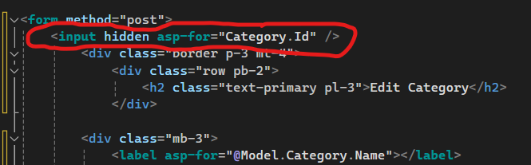

In the code page, make the following changes. Pass the id to the OnGet handler to ensure we display the correct record on the Edit Page.

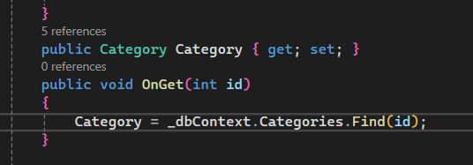

In the OnPost which will be executed when the submit action is detected. We will need to change AddAsync to Update and remove await.

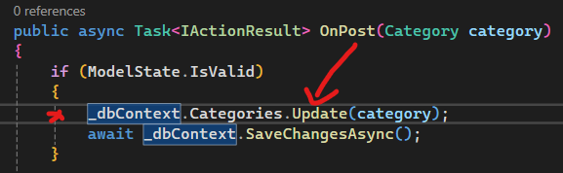
Adding button for the Edit Option
Add an anchor to the Index.cshtml page and pass in the id to the Edit page as below.

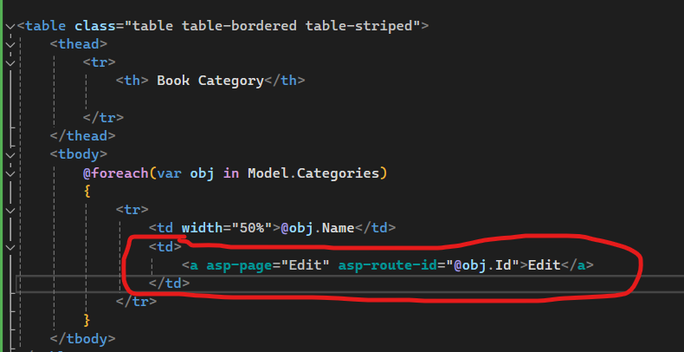

Save changes and run application. Attempt to update records.
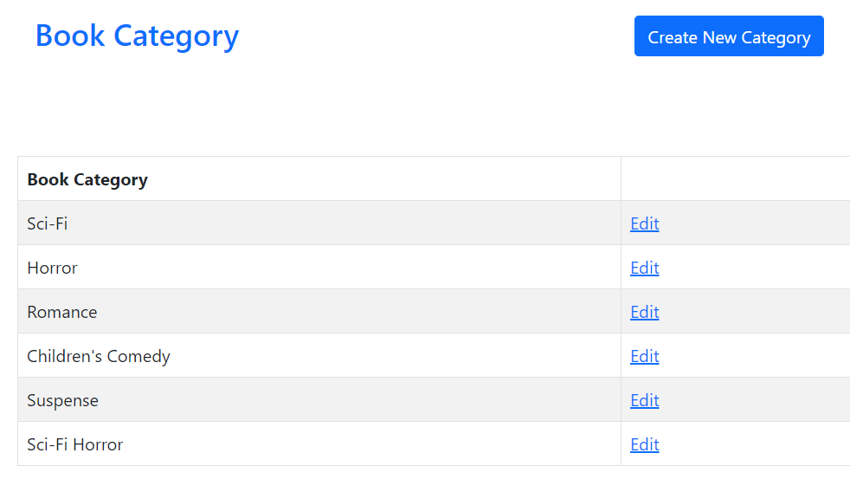
Adding Button Back to List to Edit.cshtml. Save changes and test application.
Task 5 [60 marks]

To do – 2 Tasks.
- Create a copy of the Edit.cshtml and make the necessary changes for the Delete Option. Show snippet of code for both DeleteModel.cshtml.cs and Delete.cshtml RazorPage

DeleteModel Code
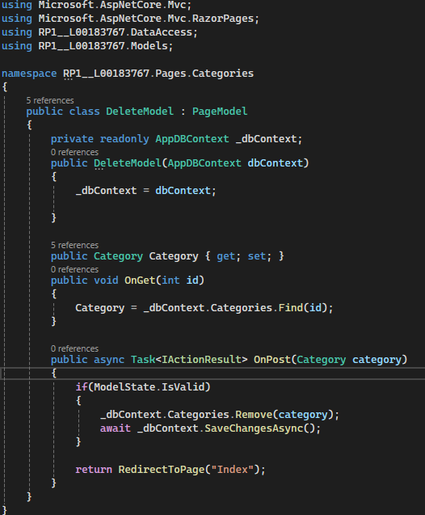

[5 marks]

Delete.cshtml Razor Page
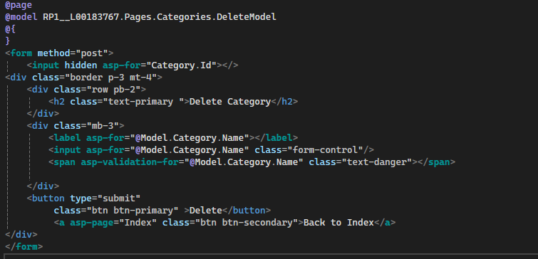

[5 marks]

- Create a new RazorPage project called MyProject-[StudentNo] e.g. MyProj-L00000.
  - This project will contain the asp.net core application which you will work with over the next 9 weeks.
  - Within the project, configure EFCore and create one principal database table and implement the CRUD operations for this table.
  - Show screen shots of the CRUD operations for your table.
  - Create a repo on Github, push and commit all changes to the remote repo. (show screen shot of repo)

[50 marks]
End of Tutorial.
Appendix
